
DIESEL GENERATING SET
MPS0450DOM

 |  | Standby Rating |  |  | Prime Rating
Voltage | Phase | kWe | kVa | Amps | kWe | kVa | Amps | p.f.
120/208 | 3 | 450 | 562 | 1562 | 405 | 506 | 1406 | 0.8
277/480 | 3 | 450 | 562 | 677 | 405 | 506 | 609 | 0.8
347/600 | 3 | 450 | 562 | 545 | 405 | 506 | 491 | 0.8
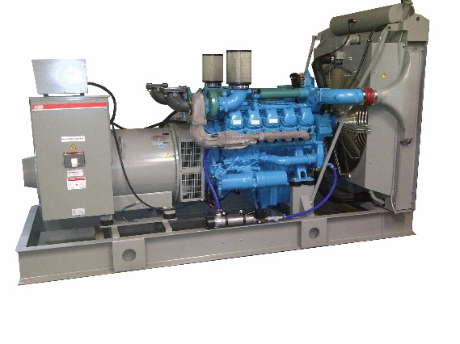

STANDARD GENERATING SET FEATURES
▪ water cooled engine | ▪ single bearing alternator | ▪ stainless steel exhaust bellows
▪ oil & fuel filters | ▪ 3 pole circuit breaker | ▪ set mounted starting batteries
▪ lube oil drain valve | ▪ auto start control panel | ▪ operation & maintenance manual
▪ 24 V dc starter and alternator | ▪ low coolant level shutdown | ▪ factory tests
▪ electronic governor | ▪ welded steel base frame | ▪ 2 yr / 2000 hour warranty
▪ standard duty air filter | ▪ integral vibration isolators

GENERATING SET PERFORMANCE

Voltage Regulation | Optimized Electrical Design | Alternator Temperature Rise
▪ +/- 0.5% voltage regulation | ▪ 4 pole brushless, 2/3 pitch winding | ▪ class H insulation
 | minimizing harmonic distortion for
Frequency Regulation | increased parallel operation | Design Specifications
▪ isochronous from no load to 100% load | performance | ▪ the alternator meets NEMA MG-1-32
with electronic governor | Random Frequency Variation | BS5000, CSA C22.2 and IEC 34
 | ▪ RTF not to exceed +/- 0.2% of its mean | Requirements
 | value for no load to full load

ENGINE SPECIFICATIONS

Doosan | Fuel System | Oil System
▪ DP158LC | ▪ mechanical fuel injection | ▪ closed crankcase vent
▪ vee block 8 cylinder engine | ▪ fuel filter | ▪ oil filter
Type | ▪ water separator
▪ water cooled 4 cycle turbocharged and | Starting | Cooling
air to air aftercooled | ▪ 24 Vdc starter | ▪ 55ºC radiator
 | ▪ 45 A battery charging alternator | ▪ pusher fan

ALTERNATOR SPECIFICATIONS
▪ brushless single bearing, revolving field | ▪ 12 lead connectable alternator | ▪ heavy duty bearing
▪ 4 pole, drip proof, screen protected | (6 lead for 347/600V) | (minimum life of 100,000 hours)
▪ class H insulation |  | ▪ direct flange mounted for proper
 |  | alignment

COMPLIANCE STANDARDS
The generating set complies with ISO 3046 & ISO 8528

STANDBY POWER RATING (ESP)
The standby power rating is applicable for supplying emergency power for the duration of the utility power outage. No overload, utility parallel or negotiated power outage operation capability is available at this rating. In installations served by unreliable utility sources (where outages last longer or occur more frequently), where operation is likely to exceed 200 hours per year, the Prime Power rating should be applied. The Standby Power rating is only applicable for emergency and standby applications where the generating set serves as the back up to the normal utility source.

PRIME POWER RATING (PRP)
Prime power is available for an unlimited number of hours per year in a variable load application, in accordance with ISO8528-1. A 10% overload capability is available for a period of 1 hour with a 12 hour period of operation, in accordance with ISO 3046-1. Variable load should not exceed a 70% average of the Prime Power rating during any operating period of 250 hours.
Technical Data MPS0450DOM
 | Standby | Prime |  | Standby | Prime
Engine Make | Doosan |  | Oil Pan Capacity | 22 L
Engine Model | DP158LC |  | Oil Change Interval | 250 h
Configuration | vee -8 |  | Exhaust flow | 101 m³/min | 93 m³/min
Displacement | 14.6 L |  | Exhaust temp | 543 ºC | 518 ºC
Bore & Stroke | 128mm x 142mm |  | Max exhaust back press | 5.9 kPa
Aspiration | turbocharged air to air aftercooled |  | Ambient Temperature | 55 ºC
Power kWm (bhp) | 513 (697) | 466 (634) | Engine Coolant Capacity | 20 L
Governor | Electronic |  | Total Coolant Capacity | 80 L
Starting | 24 Vdc |  | Radiator Cooling Air | 850 m3/min | 850 m3/min
Charging Alternator | 24 Vdc, 45A |  | Combustion Air | 34.5 m³/min | 32.3 m³/min
Alternator Make | Stamford |  | Recommended Fuel | # 2 diesel
Model | HCI534C |  | Fuel Consumption
Temperature Rise | 125 oC |  | 100 % | 124 L/hr | 112 L/hr
Insulation | Class H |  | 75 % | 91 L/hr | 83 L/hr
Bearing | Single |  | 50 % | 63 L/hr | 58 L/hr
Voltage regulation | +/- 0.5 % |  | 25 % | 35 L/hr | 32 L/hr
DIMENSIONS & WEIGHTS


 | Length (A) | Width (B) | Height (C) | Weight
Open | 3120 mm | 1400 mm | 1700 mm | 3000 kg
Silent* | 4900 mm | 1600 mm | 2300* mm | 4500 Kg
*not including sub-base fuel tank

GENERATING SET OPTIONS

Engine | Control | Others
□ Heavy Duty Air Filter | □ Paralleling EasyGen 2000
□ Air Cleaner Restriction Indicator | □ Expanded Paralleling EasyGen 3000
□ Manual Oil Drain Pump | □ Remote Annunciator
□ Oil Pan Heater | □ Utility Grade Protective Relaying
□ Coolant Heater & Thermostat | □ Remote Emergency Stop
Alternator | Electrical
□ Anti-Condensation Heaters | □ Starting Batteries
□ Increased Motor Starting | □ Battery Charger
□ PMG Excitation | □ Battery Blankets
□ Double Bearing | □ Multiple Circuit Breakers
□ Tropical Insulation Protection | □ 100% Circuit Breakers
Fuel | □ LSI(G) Trip Plugs
□ Flexible Fuel Lines | Exhaust
□ Fusible Fire Valve | □ Critical Silencer (15-20 dBA)
□ Sub-base Double Walled Fuel Tanks | □ Hospital Silencer (20-25 dBA)
□ Day Tank with Automatic Pumping | □ Hospital Plus Silencer (25-30 dBA)

Specifications may change without notice. Check with your distributor for more information www.madsen.ca
Toronto : 30 Voyager Court South- (416) 907-3844 Sarnia : 469 Polymoore Drive, Corunna - 519) 330-7387
Quebec : 96 Avenue Leacock, Pointe-Claire - (514) 971-2063 Alberta : 2029 87 Avenue, Edmonton - (780) 437-4673
Newfoundland : Glencoe Drive, Mount Pearl - (709) 726-6774 Nova Scotia : 25 Raddall Avenue, Dartmouth - (902) 468-4736

